**in2it**

**Africa**

Corporate Real Estate Management & Information Communication Technology

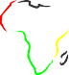

**2021**

**CORPORATE BROCHURE**

#### in2it Africa

##### Corporate Real Estate Management and Information Technology

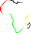

**STRATEGIC POSITIONING**

*“Value Creation for design, construction, operation and maintenance of asset / civil works through innovative business processes and digital solutions”*

Corporate Real Estate Management & Information Communication Technology

**in2it Africa**

**Competence and Offerings**

in2it Africa is a corporate real estate management company, which offers consulting services, training and customization of software and digital solutions

- with particular focus on digitalization and Building Information Modeling (BIM). The company is incorporated in Nigeria as in2CREM Ltd.

Imagine having solutions for investment planning, land acquisition, design, construction/fit-up, management, and maintenance of corporate and commercial real estate at your fingertips. Working with in2it Africa allows you to save costs and prevent problems by digitizing your building and civil works systems and training your organization on how to maintain

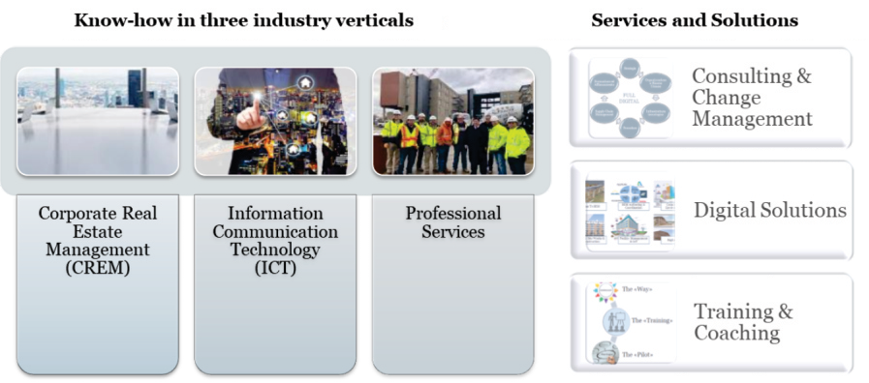

in2it *has references with major public and private contracting bodies (Figure 1).*

# Partnerships

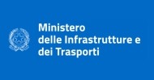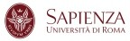**Metropolitana di Milano: Linea 4**

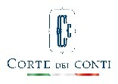

**LINEA**

**GRUPPO FERROVIE DELLO STATO ITALIANE**

***PDM S.C.p.A.***

### 



**GRUPPO FS ITALIANE**

CIVIL CONSTRUCTION



*in2it has references with major public and private contracting bodies (Figure 1).*

**REFERENCES**

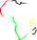

###### *“we have close affiliation with firms of* international repute and renowned for excellence.”

**Africa**

**in2it**

Corporate Real Estate Management & Information Communication Technology

in2it Africa collaborates with major training institutions, creating and delivering personalized training programs tailored to the clients' needs

– from ad hoc courses of 2 hours to postgraduate master courses covering over 300 hours of lessons.

We have partnered with Bureau Veritas and offer training courses for the certification of professional figures according to UNI 11337 *(BIM Coordinator, CDE Manager, BIM Specialist base and advanced ARC, STR and MEP).*

# Thought Leadership and Know-how

**Africa**

Corporate Real Estate Management & Information Communication Technology

**in2it**

The digital revolution ensures key advantages to users and early adopters:

1. Higher Return on Investment (ROI). BIM guarantees increases in productivity (less men-hours) and profitability (decrease in conflicts for errors and lack of coordination).
2. Faster execution of work. BIM guarantees a drastic reduction in time in the exchange of information, control and approvals
3. Higher Social Value (social marketing). The combination of 3D visualization and tailored informative contents provides transparency and knowledge of any project in an easy to understand format, even for the average citizen.
4. Real-time updated database of any asset. Immediate availability of key project information and relevant official documentation and certificates. of the work (As-Built model) always updated and accompanied by all the documentation.

The digitization of any real estate asset enables a far better way to manage its total cost of ownership (TCO) during its lifetime.

in2it Africa has agreements with various providers of software packages for the distribution of their solutions and on their behalf carries out customization activities, (ie. identification of functional specifications, training and support - Figure 3).

In this context in2it covers the full spectrum of the relevant ICT solutions for the digitization of the CREM supply chain. We continuously scout potential solutions providers in 6 core-categories.

1. Scan to BIM
2. BIM Authoring and Coordination
3. Common Data Environment(s)
4. Digital Site Works and Construction
5. Facility Management and IoT
6. Digital Twins

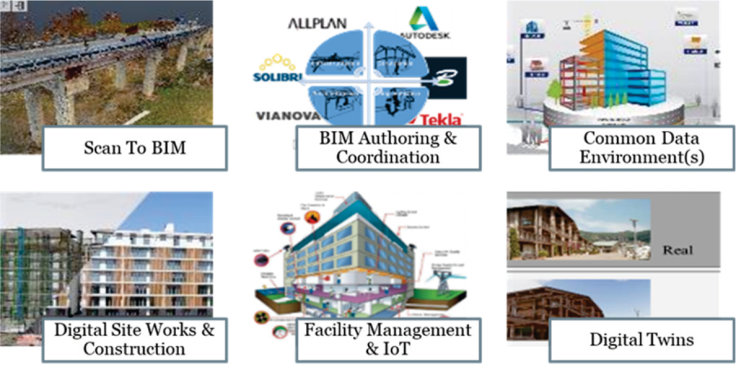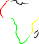

*Figure 3:* in2it *experience in the field of training and creation of specialist content*

**International Network**

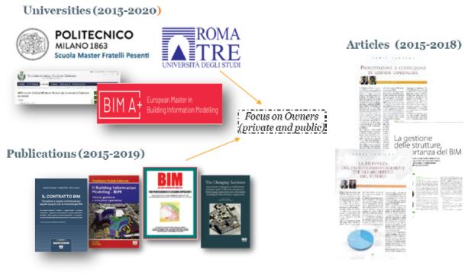 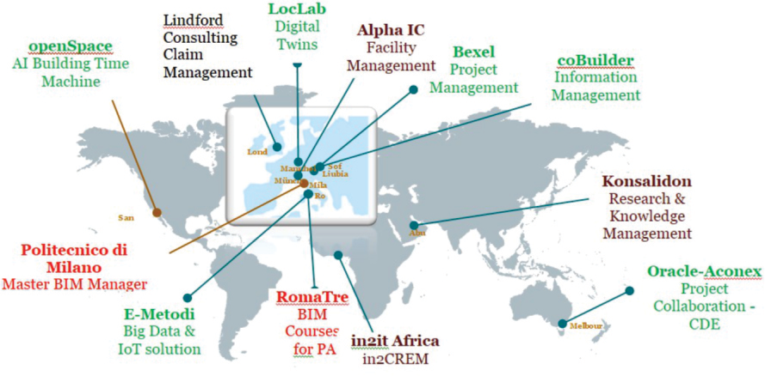

###### *Figure 4: processes within international accredited bodies.*

Corporate Real Estate Management & Information Communication Technology

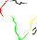

**in2it Africa**

# Serving The Whole Value Chain

## DIGITIZATION

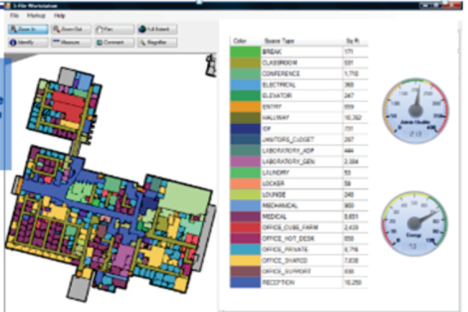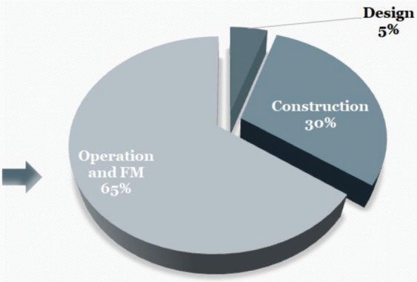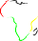

###### *Figure 5: Categories of ICT solutions offered by in2it and/or its* technology partners

**Africa**

**in2it**

Corporate Real Estate Management & Information Communication Technology

## DATA REEQUIREMENTS

###### *What do I own?*

* *What is the condition of my assets?*

###### *Where are they?*

* *How long will they still function?*
* *What is their economic value?*

# Digital Facility Management

We know that everybody strives to increase the value of its real estate assets.

in2it considers efficient facility management key to managing any asset portfolio while relying on key data for the operation of building systems and its components.

Proper facility management starts from disposing strategic key information and keeping them updated:

**PROCESSES**

###### *Proper facility management starts from disposing strategic* key information and keeping them updated: .

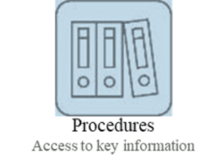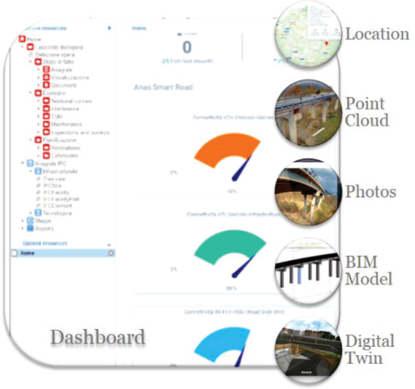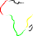

**Africa**

**in2it**

Corporate Real Estate Management & Information Communication Technology

###### *Figure 6: Dashboard with external links to real-time data and sensors*

*Figure 7: processes within international accredited bodies.*

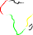

**Digital Facility Management**

Corporate Real Estate Management & Information Communication Technology

**in2it Africa**

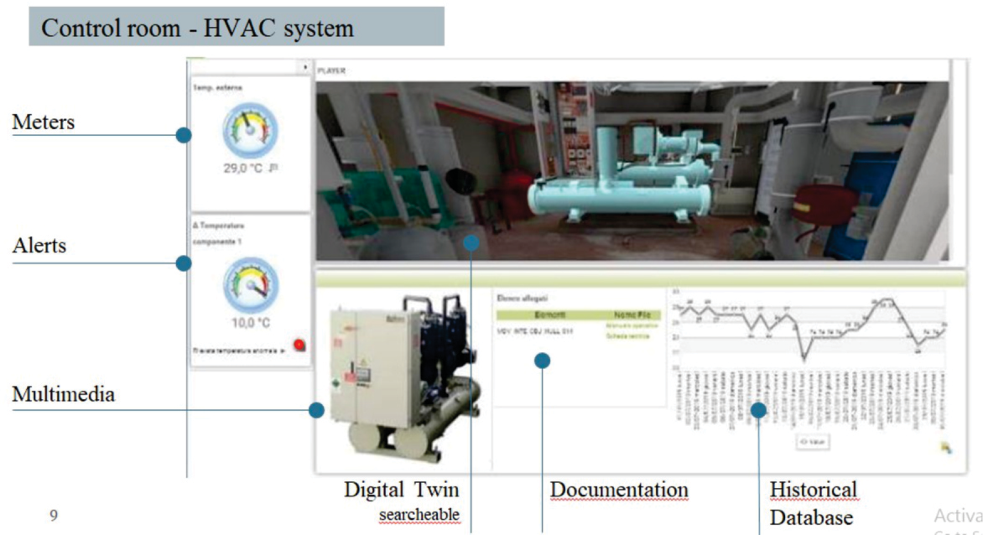

# Organization and Management

**Africa**

Corporate Real Estate Management & Information Communication Technology

**in2it**

**MARIO CAPUTI**

in2it Africa has permanent employees and strategic partners and covers 5 business areas as shown in Figure 6.

Senior Executive and Managing Director @ in2it Faculty Member @ BIM Manager Master of *Politecnico di Milano*.

Industry Focus: Digitalization (BIM Methodology and Facility Management.

Functional experience in Change Management, Global Sourcing, Process and Organization Redesign

**PAUL ERUBAMI**

Experienced Facility Manager, Industrial Engineer & Sustainability Expert

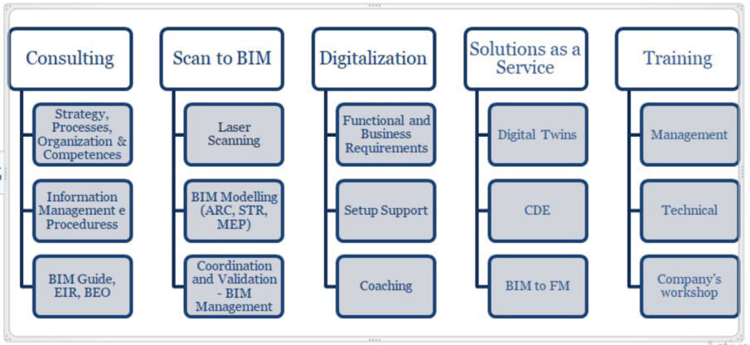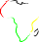

Lecturer at the *University of Lagos* Masters in FM program

IFMA qualified trainer for CFM, FMP and SFP Credentials

Industry Focus: Oil and Gas, Telecoms, and Corporate Real Estate

Functional experience in Strategy Implementation, Technology Deployment, Operations systems and Processes Change Management

*Figure 5: Organization of* in2it

**in2it**

**Africa**

Corporate Real Estate Management & Information Communication Technology



Get in touch

**in2it Africa**

##### Human Resources Development Center Building, University of Lagos Main Campus,

Akoka, Yaba, Lagos. [africa@in2it.it.](mailto:africa@in2it.it)

##### +2348159802570